DESIGN AND ANALYSIS OF RECONFIGURABLE ANTENNA

Dr.S.Rajasekaran
Electronics and CommunicationEngineering
Madanapalle Institute ofTechnology and Science
Madanapalle,India
srsmeae@gmail.com
Salomi Avula
Electronics and Communication Engineering
Madanapalle Institute of Technology and Science Madanapalle,India
avulasalomi23 @gmail.com
Rajeswari Orsu
Electronics and Communication Engineering
Madanapalle Institute of Technology and Science Madanapalle,India
rajeswariorsu2 @gmail.com

Thulasi Nikhila Challa
Electronics and Communication Engineering
Madanapalle Institute of Technology and Science
Madanapalle,India
challathulasinikhila@gmail.com

Abstract— A reconfigurable antenna is designed by using the CST Studio by changing multiple frequencies. In this paper, we designed a reconfigurable antenna and used three pin diodes as switches to obtain different resonant frequencies. The feature of reconfigurability is attained by using Pin Diodes. In this design, we take a 3pin diode. The proposed Antenna can operate on different frequencies i.e., 2GHz, 11GHz with the efficiency of 90% and more at different conditions of the diodes the proposed antenna is used for the following applications: aeronautical radio navigation [4.3 GHz], AMT fixed services [4.5 GHz], WLAN [5.2 GHz], Unlicensed WiMAX [5.8 GHz] and X-band [7.5 GHz]. This analysis is done by using CST Studio.
Keywords— Reconfigurable Antenna, Pin Diode, X-band, AMT fixed services, microstrip feed line.
1.Introduction
Reconfigurable antenna on multiple frequency bands have a bunch of applications in modern wireless communications. The reconfigurable antenna can reconfigure the characteristics such as resonant frequency, polarization and radiation pattern. The reconfigurable antenna work dynamically by changing the different switching mechanisms. The switching mechanisms are done by using different switches like varactor diodes, Pin Diodes and RF MEMS switches. Each and every switch has its own advantages. The varactor diodes are used for reconfiguration of antenna, but these are nonlinear and narrow in nature. The pin diodes that increases the insertion loss and complicates the biasing circuitry [4]. Although there are many switching methods available, including RF memes and varactor diodes. Because of its high linearity, high speed response, low noise, cheap cost, and greater reliability, we have decided to use a pin diode as our switch [5]. Although RF MEMS has a minimal loss, its implementation is expensive [6]. The Pin diode is intended to function in three states, but the design is complicated [7]. Omnidirectional at 2.4 GHz, unidirectional at 5.4 GHz, and simultaneous omnidirectional and unidirectional operation are its three working modes. Six RF pin diodes were used in the suggested frequency reconfigurable pixel antenna, but only three resonant frequencies and minimal cross polarization were obtained. A small, slotted micro strip patch antenna that operates at WiMAX frequencies using two pin diodes [8]. A small frequency-configural antenna is used for Bluetooth, WLAN, and WiMAX applications using a straightforward square-shaped radiating patch [9]. Flexible antennas have been fed using a variety of methods, but coplanar waveguide feeding is preferred because the antenna element and patch on the same side of the substrate, which simplifies the design[10]. The T-shaped antenna for WLAN and WiMAX apps uses a single pin diode[11]. This paper proposes an innovative, small, flexible, and frequency-configurable antenna. This design adds flexibility and reconfiguration, making it appealing for conformal and numerous other uses. Switches are used to alter the radiator's electrical length, which in turn alters the harmonic frequency. Thus, frequency reconfiguration is feasible for five different applications in the proposed design by using switches at the right places. For applications such as Aeronautical Radio Navigation (ARN), AMT fixed Services, WLAN, WiMAX, and X-band, a brand-new, compact, flexible, and frequency-configurable antenna is suggested. Every time the switches are in the On or Off position, useful frequency bands are obtained.
Due to their low size, light weight, and durability, flexible antennas have recently become very important. The crescent-shaped antenna is demonstrated using flexible RO4003 Rogers with an impedance bandwidth of 7.1 GHz, and various flexible substrates have been reported. In Paper-based antenna for 2.4 GHz WLAN application, Kapton® polyamide-based multi-band antenna is suggested. Utilizing flexible antennas, dual frequency rejection at 5.25 GHz and 5.775 GHz is effectively accomplished.
2.ANTENNA DESIGN AND RECONFIGURATION
In this antenna uses Flexible Rogers RT/Droid 5880 as a substrate. Designed The substrate has a dielectric constant of 2.2 and a loss tangent of 0.0009 with a thickness of 0.508 millimeters. The compact size of antenna that is the length and the width are 30 mm × 28.4 mm and microstrip line of 50 ohms. The dimensions of the substrate are width (Wg), length(Lg) are (Wg×Lg)of the antenna are (13.45×14.642) mm. The switching mechanism can be achieved by using P-I-N diodes. The proposed antenna has given the 3 slots and by using 2 switches we can operate the antenna in different frequencies. The proposed design is shown fig1. The inner and outer radiator is connected to the main radiator via switch S1 and S2.for inner radiator the number of segments used are 8 and for the outer radiator the number segments used are 6. The operating frequency of the reconfigurable antenna ranges between 2GHz to 11GHz.

Figure 1. Proposed Antenna Model
The diodes are used in this design are P-I-N diodes, these are used for proper biasing. When the PIN diode is ON it provides low impedance and when it is OFF it provides high impedance. Two diodes are used in the proposed model to switch from one resonant frequency to another frequency. The symbol and schematic diagram at 0N and OFF conditions were shown figure 2 and figure 3.
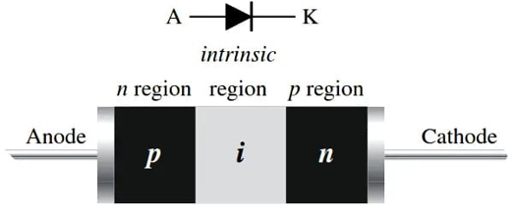
Figure 2. Symbol and Structure of Pin Diode
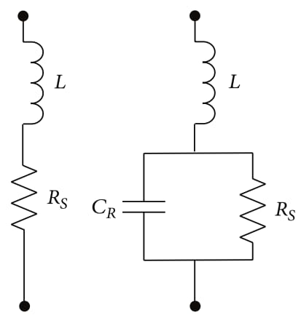
Figure 3. On and off states of Pin Diode

Simulation Results
The below parameters represent the antennas electrical characteristics. The plot represents the s parameter simulation results of a reconfigurable antenna between the frequency range of 2 to 11GHz. Along with that the simulation results are taken in three different cases they are when both the switches s1 and s2 are on, both switches S1&S2 are off, and the final case is when one switch S1 is on and the other switchS2 is off. When both S1 & S2 are shorted simultaneously, the current circulates in the main radiator as well as in the inner and outer radiator. When both S1 and S2 are open, the current circulates only in the main radiator.
The S-parameters of a reconfigurable antenna are critical in characterizing its performance and functionality. S-parameters are complex-valued coefficients that represent the linear response of the antenna to an electromagnetic wave at a specific frequency. The scattering matrix (S-matrix) is a comprehensive representation of the antenna’s behavior, and it can be used to evaluate critical performance parameters such as input impedance, return loss, and bandwidth. For reconfigurable antennas, S-parameters can vary depending on the configuration of the antenna, and it is important to measure and analyze them in both the on and off states of any switching elements or components. Accurate measurement and analysis of S-parameters can help optimize the design of reconfigurable antennas, leading to improved performance, versatility, and adaptability.

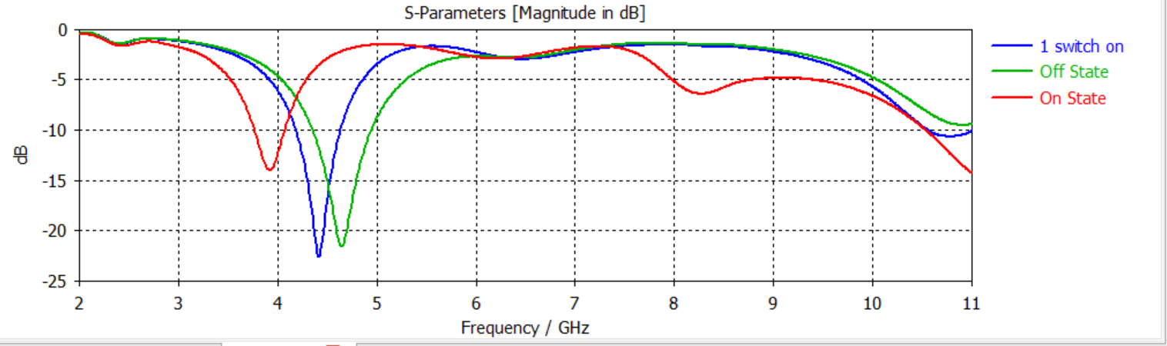
Graph 1.S Parameter comparison of reconfigurable antenna in different conditions
The below figure 5 represents the VSWR results at different conditions such as when both the switches s1 and s2 are on, both switches S1&S2 are off, and the final case is when one switch S1 is on and the other switchS2 is off.The terms i.e., Voltage Standing Wave Ratio refers to how much power is radiated back.
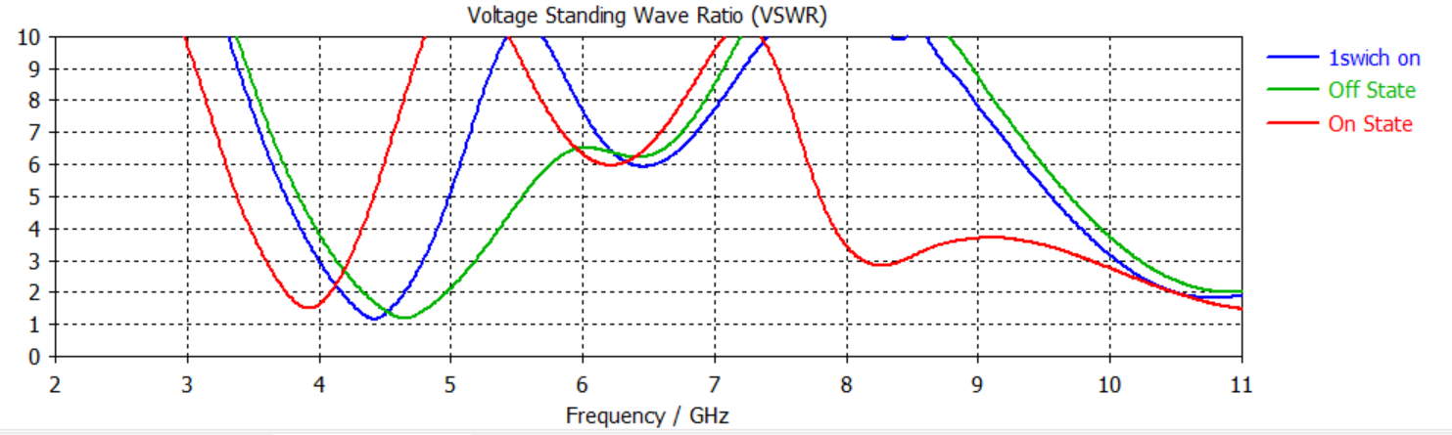
Graph 2. VSWR plot for the diode all conditions
The term VSWR i.e., Voltage Standing Wave Ratio refers to how much power is radiated back. The above fig.5 shows the VSWR plots for diode all conditions. Theoretical condition states that the curve between 2 to 11 means there will be less reflections.
RADIATION PATTREN:
Far-field radiation pattern
The radiation pattern can be tridimensional function or bidimensional. In The latter case the radiation pattern represents a cut of the 3D radiation pattern. The 2D gain pattern of a lamda/2 dipole antenna.

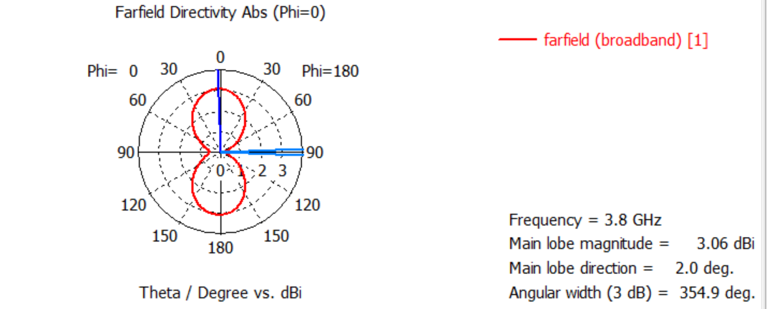
(a)
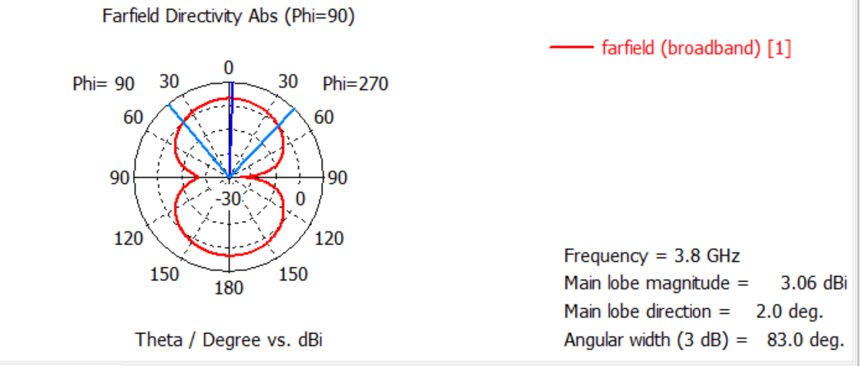
(b)
Figure 4 (a) and (b) shows far-field radiation pattern of the Reconfigurable antenna when both switches on and phase shift is 0 and 90.

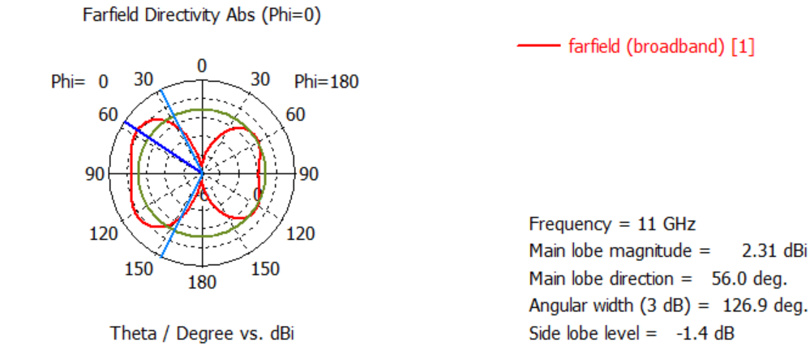
(a)
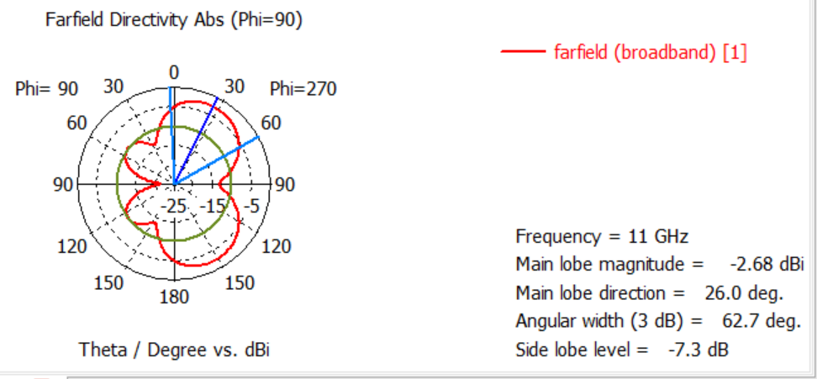
(b)
Figure 5 (a) and (b) shows far-field radiation pattern of the Reconfigurable antenna when both switches off and phase shift is 0 and 90.
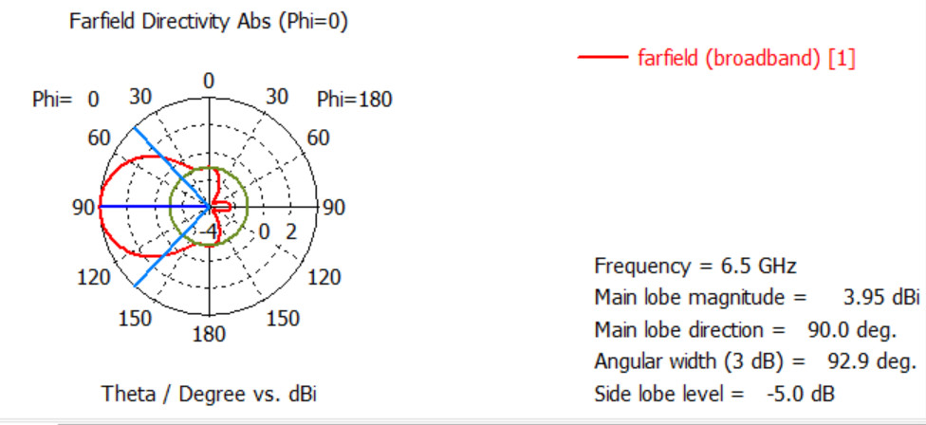
(a)
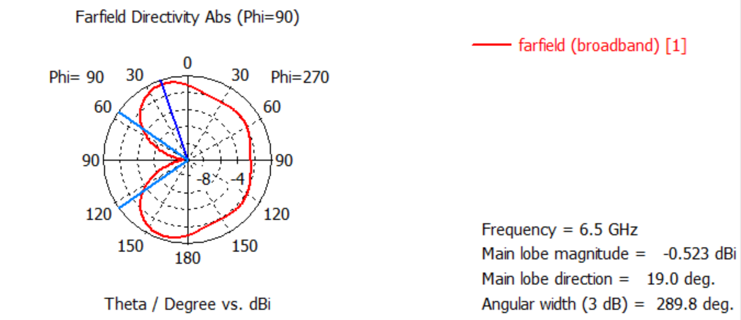
(b)
Figure 6 (a) and (b) shows Far-field radiation pattern realization of the Reconfigurable antenna when one switch is on, and phase shift is 0 and 90.
In the field of antenna design the term radiation pattern (or antenna pattern or far-field pattern) refers to the directional(angular) dependence of the strength of the radio waves from the antenna or other source.

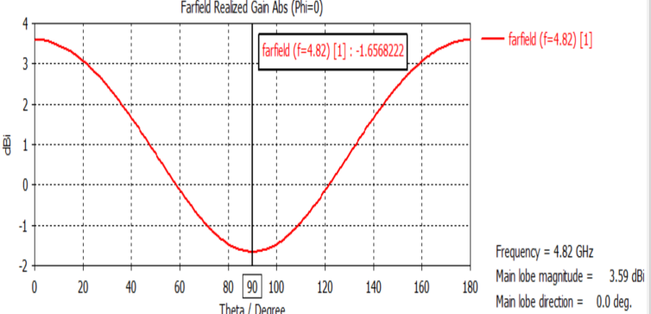
Graph 3 far-field radiation pattern realization of the Reconfigurable antenna when phase shift is 0.

The far field is a critical consideration in the design of antennas, including reconfigurable antennas. The far field region is the region in space where the radiation characteristics of the antenna are independent of its distance from the antenna, and it is where the radiated energy is most useful for communication purposes. The far field region is typically defined as the region beyond the so-called Fresnel distance, which is proportional to the square of the antenna size and the wavelength of the radiation. The far field radiation pattern of an antenna is determined by its geometry, the nature of the current flowing on the antenna, and the properties of the surrounding medium. The far field radiation pattern can be measured experimentally and can be used to evaluate critical parameters such as directivity, gain, and efficiency. For reconfigurable antennas, the radiation pattern can be dynamically adjusted to optimize performance, and the far field pattern can be used to evaluate the effectiveness of these adjustments. Overall, the far field is a crucial consideration in the design of reconfigurable antennas, as it determines the efficiency and effectiveness of the radiated energy for communication purposes.
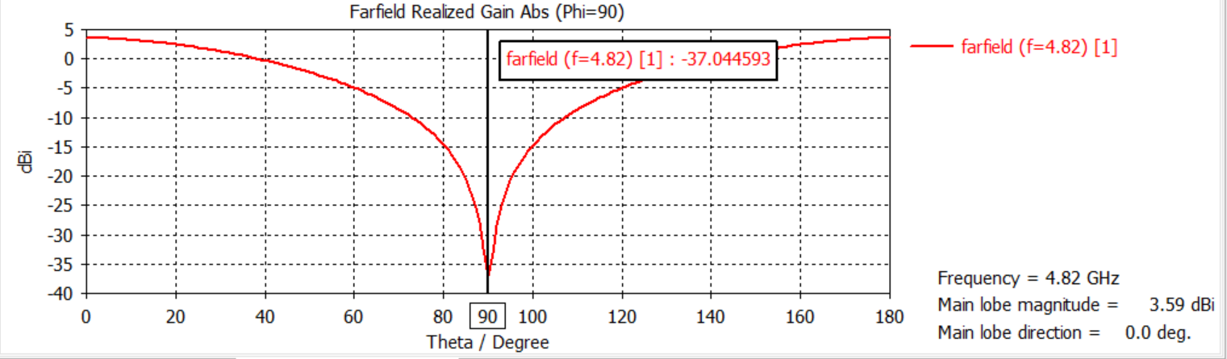graph 4 far-field radiation pattern realization of the Reconfigurable antenna when phase shift is 90

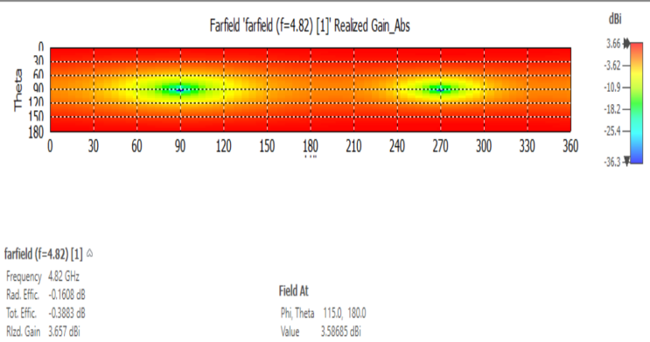
Figure 7 shows 2D radiation pattern realization of the Reconfigurable antenna
3D-radiation pattern
Three-dimensional antenna radiation patterns. The radial distance from the origin in any direction represents the strength of radiation emitted in that direction. The top shows the directive pattern of a horn antenna, the bottom shows the omnidirectional

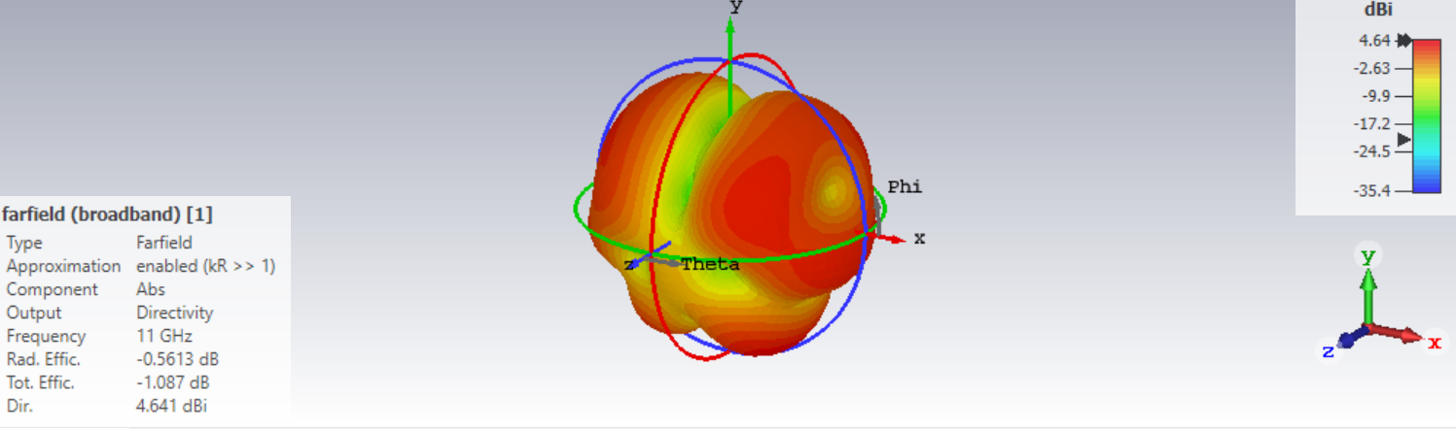
Figure 8 shows 3D radiation pattern realization of the Reconfigurable antenna when both switches are off.
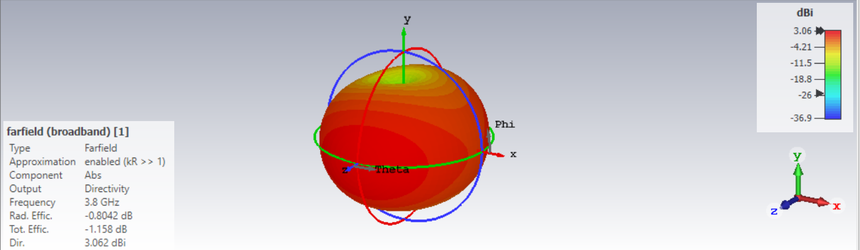

Figure 9 shows 3D radiation pattern realization of the Reconfigurable antenna when both switches are on.
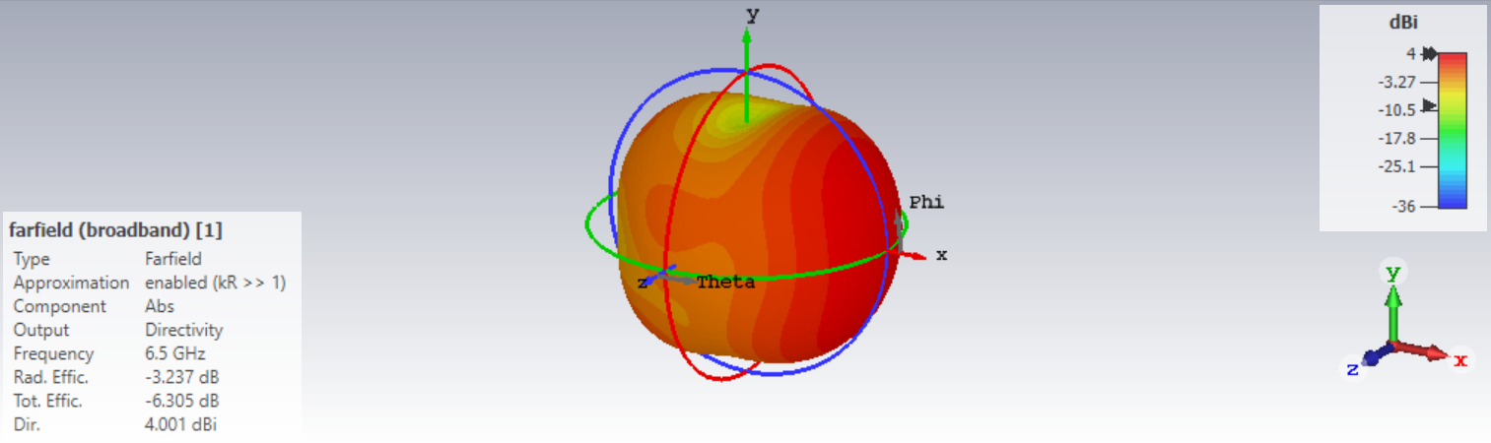
Figure 10 shows 3D radiation pattern realization of the Reconfigurable antenna when one switch is 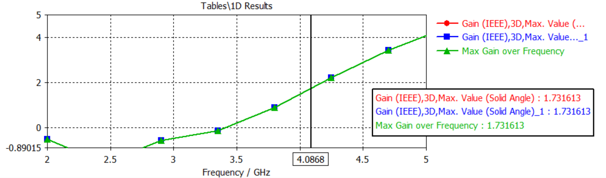
Figure 11 Max gain over frequency when both switches are off.
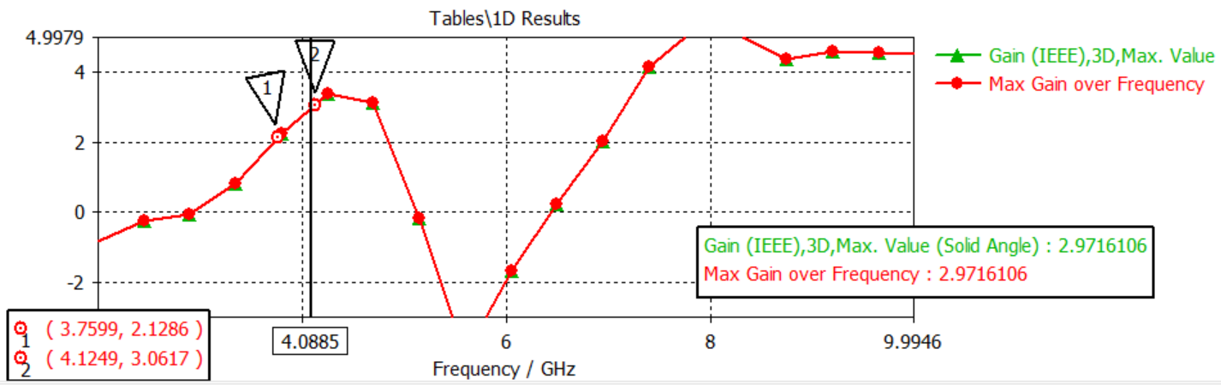
Figure 12 Max gain over frequency when both switches are on.
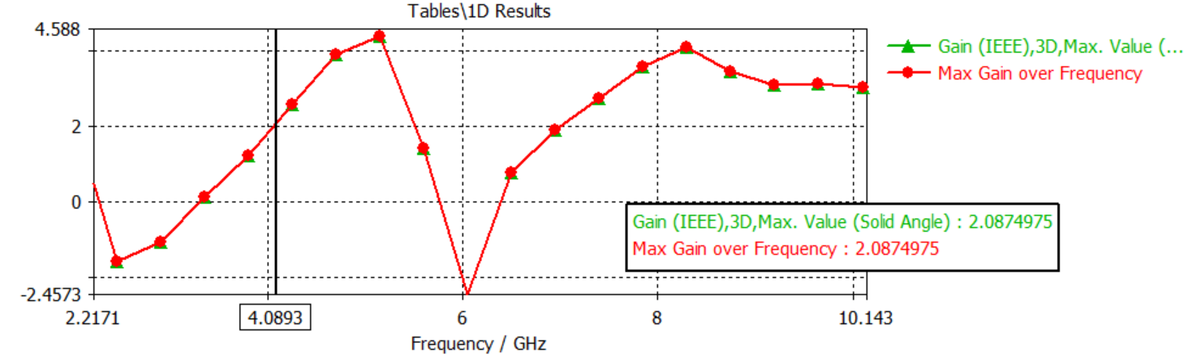
Figure 13 Max gain over frequency when both switches are on.

Table 1. Parameters of Antenna
S.no | Label | Dimension(mm)
1. | Wg | 13.45
2. | Lg | 14.642
3. | W | 28.4
4. | L | 30
5. | Lr | 3
6. | wr | 11
7. | wt | 5.2
8. | F | 1
9. | R1 | 1.5
10. | R2 | 2.5
11. | G1 | 0.25
12. | G2 | 1.15
13. | G | 0.358
14. | Gx | 3.5
15. | M | 5.3
16. | D | 5.5
17. | st | 0.508
18. | ct | 0.035

The parameters of a reconfigurable antenna can vary depending on the specific configuration and intended application, but some common parameters include:
Frequency: The frequency range over which the antenna operates and can be reconfigured. Bandwidth: The range of frequencies over which the antenna provides acceptable performance, including parameters such as gain and efficiency. Polarization: The polarization state of the antenna, which can be reconfigured to match the polarization of the incoming signal. Radiation pattern: The directional properties of the antenna, which can be reconfigured to adjust the direction of maximum radiation, beamwidth, and gain. Impedance: The characteristic impedance of the antenna and its matching network, which can be reconfigured to match the impedance of the transmitter or receiver. Switching speed: The speed at which the antenna can be reconfigured, which is important for applications where rapid adaptation to changing communication conditions is necessary. Power handling: The maximum power that the antenna can handle without damage. Size: The physical size of the antenna, which can affect its performance and versatility. Complexity: The level of complexity of the antenna design and its associated reconfigurability, which can affect factors such as cost, reliability, and ease of implementation.
Overall, the specific parameters of a reconfigurable antenna depend on the intended application, and careful consideration must be given to their design and optimization to ensure optimal performance and adaptability.

CONCLUSION:
In conclusion, the design of reconfigurable antennas is an active area of research that has significant potential for improving the performance and functionality of wireless communication systems. Reconfigurable antennas offer the ability to dynamically adjust their radiation properties, such as frequency, polarization, and beam direction, to adapt to changing communication requirements. Various techniques, such as frequency reconfigurability, polarization reconfigurability, and beam steering, can be used to achieve this adaptability. The design of reconfigurable antennas involves a combination of theoretical analysis, numerical simulations, and experimental measurements, and requires careful consideration of factors such as antenna size, bandwidth, efficiency, and complexity. Future work in this area is likely to involve the integration of reconfigurable antennas with other technologies, the use of novel materials and fabrication techniques, and the optimization of antenna designs using advanced techniques such as machine learning and genetic algorithms.

References
- G. Eason, B. Noble, and I. N. Sneddon, “On certain integrals of Lipschitz-Hankel type involving products of Bessel functions,” Phil. Trans. Roy. Soc. London, vol. A247, pp. 529–551, April 1955. (references)
- J. Clerk Maxwell, A Treatise on Electricity and Magnetism, 3rd ed., vol. 2. Oxford: Clarendon, 1892, pp.68–73.
- I. S. Jacobs and C. P. Bean, “Fine particles, thin films and exchange anisotropy,” in Magnetism, vol. III, G. T. Rado and H. Suhl, Eds. New York: Academic, 1963, pp. 271–350.
- K. Elissa, “Title of paper if known,” unpublished.R. Nicole, “Title of paper with only first word capitalized,” J. Name Stand. Abbrev., in press.
- Y. Yorozu, M. Hirano, K. Oka, and Y. Tagawa, “Electron spectroscopy studies on magneto-optical media and plastic substrate interface,” IEEE Transl. J. Magn. Japan, vol. 2, pp. 740–741, August 1987 [Digests 9th Annual Conf. Magnetics Japan, p. 301, 1982].
- M. Young, The Technical Writer’s Handbook. Mill Valley, CA: University Science, 1989.
- CETINER, B. A., CRUSATS, G. R., JOFRE, L., et al. RF MEMS integrated frequency reconfigurable annular slot antenna. IEEE Transactions on Antennas and Propagation, 2010, vol. 58, no. 3, p. 626–632. DOI: 10.1109/TAP.2009.2039300
- YANG, X. L., LIN, J. C., CHEN, G., et al. Frequency
reconfigurable antenna for wireless communications using GaAs FET switch. IEEE Antennas and Wireless Propagation Letters, 2015, vol. 14, p. 807–810. DOI: 10.1109/LAWP.2014.2380436
- BHELLAR, B., TAHIR, F. A. Frequency reconfigurable antenna for handheld wireless devices. IET Microwaves, Antennas & Propagation, 2015, vol. 9,no.13, p.1412–1417. DOI:10.1049/iet-map.2015.0199
- CHEN, G., YANG, X. L., WANG, Y. Dual-band frequency-reconfigurable folded slot antenna for wireless communications. IEEE Antennas and Wireless Propagation Letters, 2012, vol. 11, p. 1386–1389. DOI: 210.1109/LAWP.2012.2227293
- HAN, L., WANG, C., CHEN, X., et al. Compact frequency-reconfigurable slot antenna for wireless applications. IEEE Antennas and Wireless Propagation Letters, 2016, vol. 15,]
- Wu, Z. H., Wang, Z., & Zou, X. (2016). Reconfigurable antennas: design and applications. John Wiley & Sons.
- Chen, X., & Werner, D. H. (2011). Reconfigurable antennas: a review of recent developments. IEEE Transactions on Antennas and Propagation, 59(8), 2716-2730.
- Jolani, F., & Sarabande, K. (2015). Design of reconfigurable antennas using RF MEMS technology. IEEE Transactions on Antennas and Propagation, 63(10), 4341-4351.
- Gao, S., Ammann, M. J., & Zürcher, J. F. (2013). Design and optimization of reconfigurable antennas for cognitive radio applications. IEEE Transactions on Antennas and Propagation, 61(7), 3474-3484.
- Li, X., & Werner, D. H. (2019). Reconfigurable antennas for wireless communication systems. IEEE Antennas and Propagation Magazine, 61(1), 48-63.
- Huang, J., & Xue, Q. (2017). Design of reconfigurable antennas for cognitive radio systems. IEEE Access, 5, 21007-21019.
- Abbasi, A., Salim, M. A., & Ullah, S. (2020). Reconfigurable antennas: current state-of-the-art and future trends. Electronics, 9(4), 562.
- Oraizi, H., & Keshtgari, M. (2018). A review of reconfigurable antenna for wireless communication. International Journal of Communication Networks and Information Security, 10(3), 89-96.
- Cui, Y., & Guo, Y. (2015). Design of reconfigurable antennas for cognitive radio applications. IET Microwaves, Antennas & Propagation, 9(13), 1421-1428.
- Ali, R., & Gogineni, S. (2017). A review on the design of reconfigurable antennas. International Journal of Electronics, 104(8), 1344-1361.
- Yang, F., & Rahmat-Samii, Y. (2014). Electromagnetic optimization of reconfigurable antennas. John Wiley & Sons.
- Rao, K. V. S. V., & Reddy, K. R. (2018). A review on reconfigurable antenna for cognitive radio applications. Journal of Microwaves, Optoelectronics and Electromagnetic Applications, 17(3), 247-262.
- Sahu, S., & Patnaik, S. (2016). Reconfigurable antennas for cognitive radio applications: a review. Journal of Electrical and Computer Engineering Innovations, 4(1), 24-35.
- Mishra, D., & Yadav, R. (2016). Design and analysis of reconfigurable antennas for cognitive radio applications. International Journal of Electronics, 103(2), 236-259.
- He, S., & Li, Y. (2016). Design and optimization of reconfigurable antennas for cognitive radio systems. IEEE Access, 4, 949-957.
- Boutejdar, A., & Kaiser, T. (2018). Reconfigurable antennas for cognitive radio: a survey. Wireless Personal Communications, 101(4).
- Gao, S., Ammann, M. J., & Zwick, T. (2013). Novel reconfigurable antennas based on liquid metal. IEEE Transactions on Antennas and Propagation, 61(11), 5599-5607.
- Hao, Z. C., & Wen, G. Y. (2012). A frequency reconfigurable antenna using RF MEMS switches. IEEE Transactions on Antennas and Propagation, 60(10), 4906-4910.
- Han, S., & Kim, Y. (2011). A novel compact reconfigurable antenna for WLAN/WiMAX applications. IEEE Antennas and Wireless Propagation Letters, 10, 622-625.
- Ali, M., & Khan, F. U. (2018). A review on different types of reconfigurable antennas for wireless applications. Journal of Sensors, 2018, 1-22.
- Khandelwal, N., & Chaudhary, R. K. (2017). A review on reconfigurable antennas for modern wireless communication systems. Journal of Microwave Engineering and Technologies, 1(1), 1-12.
- Li, Y., Liang, J., & Li, C. (2013). Frequency reconfigurable antennas using varactors: a review. International Journal of Antennas and Propagation, 2013, 1-14.
- Azam, S., Ahmad, S., & Qaraqe, K. A. (2019). Reconfigurable antennas and their applications: a review. IET Microwaves, Antennas & Propagation, 13(14), 2489-2497.

